Mapping Information Platform
Rapid Query Tool Quick Reference Guide

Version 1.0
June 2007
Table of Contents

Purpose 1
Document Organization 1
1. Introduction to Business Objects 2
1.1. Overview 2
1.2. Starting Business Objects 2
2. Building Queries 4
2.1. Overview 4
2.2. Objects, Classes and Universes 4
2.3. Building and Running a Query 6
2.4. The Query Process 7
2.5. Documents 8
2.6. Building a Query 9
2.7. Editing the Results of a Query 12
2.8. Understanding the Report Manager 12
2.9. Setting Up a Master/Detail Report 14
3. Conditions 17
3.1. Overview 17
3.2. Understanding Query Conditions 18
4. Manipulating Data using Simple Calculations, Sorts, and Filters 22
4.1. Overview 22
4.2. Manipulating Tables 23
5. Scheduling and Emailing Reports 29

Purpose
The purpose of this document is to provide an introduction for business users to query, create reports, and analyze data, using the MIP Rapid Query Tool, which has been developed using BUSINESSOBJECTS™. The Rapid Query Tool will be referred to as “Business Objects” in this document.

Note: at this time, the Rapid Query Tool has only been tested with Internet Explorer (IE) 6 as well as IE7. It has not yet been tested with Firefox Mozilla.

Document Organization
- Create Business Objects Documents and build Queries
Describes how to build and run simple queries to retrieve data through a Business Objects Universe.
- Conditions
Describes how to set up query conditions. By using query conditions, you can limit the data returned from the underlying database.
- Manipulating Data using Simple Calculations, Sorts and Filters
Describes how to resize columns and rows in tables, change the order in which columns are displayed, add simple calculations and apply sorts and filters.

Introduction to Business Objects

Overview
This module provides an overview of the Business Objects environment.

What you will be able to do

At the end of this module, you will be able to do the following:
- Start Business Objects

Starting Business Objects
When you start Business Objects, you will be asked to log in. In order to log in you will need two things:
- A user name
- A password

- Using your web browser, open the Business Objects URL, to display the Business Objects Log On screen.

Use the following URL:

https://hazards.fema.gov/boportal/businessobjects/enterprise115/desktoplaunch

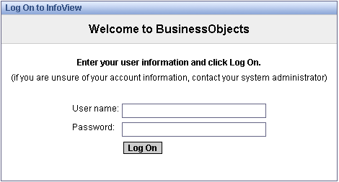

- Type your user name in the User Name field.
- Type your password in the Password box.

After logging in, you will be presented with the Home page for the Business Objects environment.

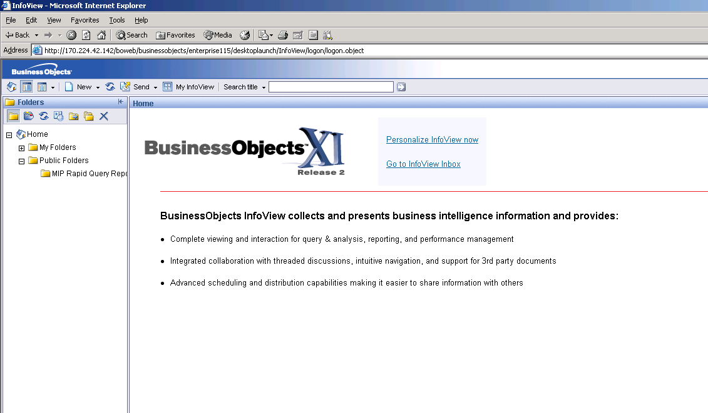

Building Queries

Overview
This module describes how to build and run queries to create reports and retrieve data through a Business Objects Universe.

What you will be able to do

At the end of this module, you will be able to:

- Create a new document
- Build a simple query to retrieve data from a single data source
- Edit the result of a query
- Interactively create and edit reports with drag-and-drop
- Read a report map

Objects, Classes and Universes

Objec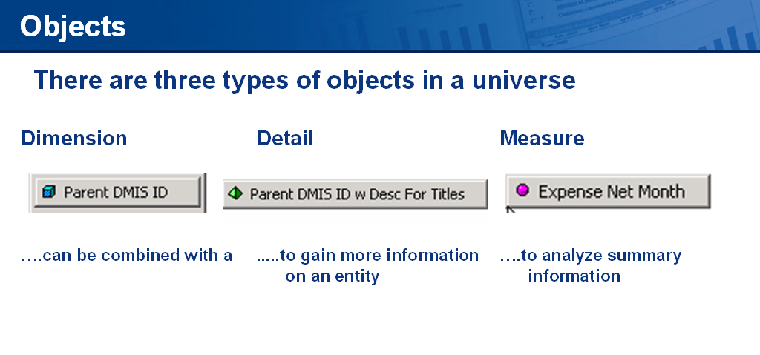t

Objects are elements in a Universe that correspond to a selection of data in the database. Object names are often the same business terms used in everyday activities. For a Human Resources manager, objects might be Employee Name, Address, Salary, or Bonus, while for a financial analyst, objects might be Profit Margin, Return on Investment, etc.

You use objects to build queries and to retrieve data for your reports. For the purposes of multidimensional analysis, objects are qualified as one of three types:

- Dimension Objects are key objects and will be the basis for most of your queries. Measure Objects typically retrieve character-type data (patient/provider names, hospital location id, etc.), or dates (years, quarters, effective dates, etc.). For example, a dimension called 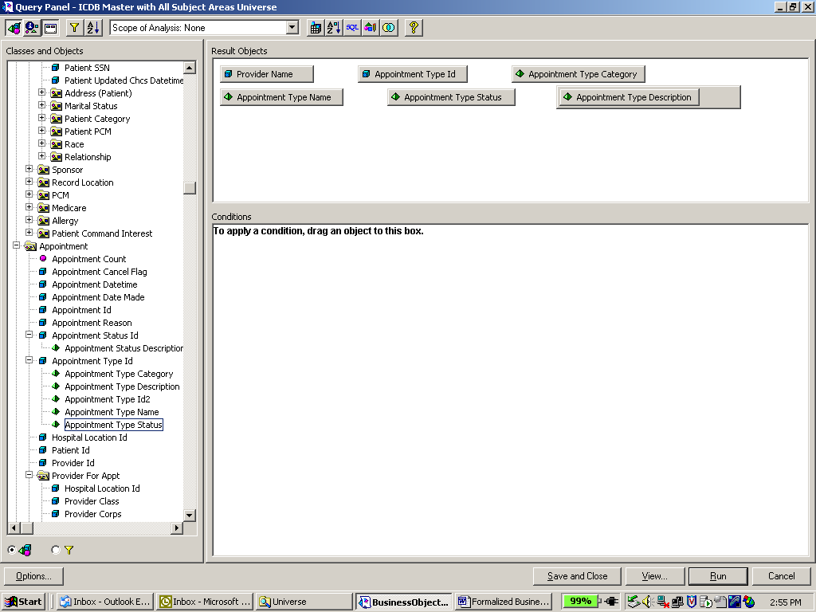 will return the ID’s of Appointment types.

- A Detail Object is always associated with a Dimension Object, for which it provides additional information. You might want to see this information in a report, but it would not form the basis of a query. For example, a Detail Object called would be associated with .
- Measure Objects are always numeric data that is the result of calculations on data in the database – they represent a dynamic aggregate. For example, the Measure Object 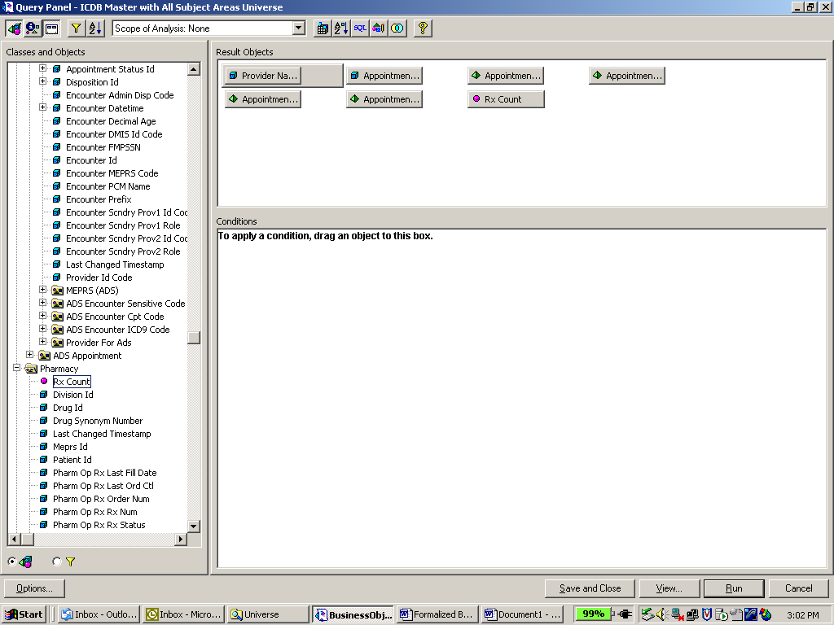 would be based on the calculation: Count of all Rx Numbers.

Measure Objects are semantically dynamic: the values they return depend on the Dimension Objects they are used with in a query.

If you make the query:
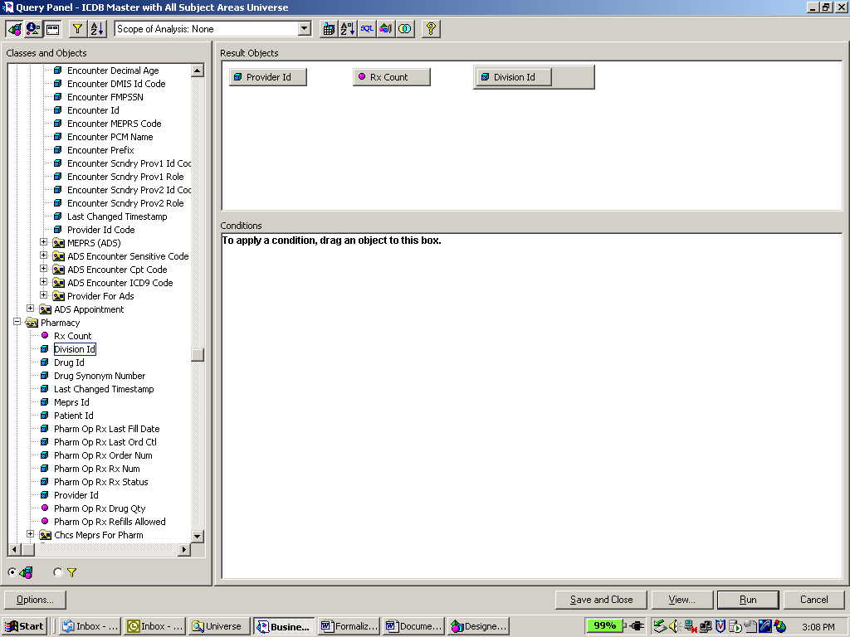

and then, using the same Measure Object, make the query:

the resulting Rx Count figure per row in the query result will be different.

Dimension and Detail Objects are based on a value in a database, so their contents are fixed.

Object formats
Universe designers apply formats to objects when creating Universes. The formats apply to the data values displayed in the cells of your reports. Format options include settings for numbers, alignment, font, border and shading.

Classes
Classes are logical groups of related objects. For example, a date class would typically contain Year, Quarter and Month Dimension Objects.

Universes
A Universe is a logical group of classes. It gives access to data that reflects different operations within a company.

For example, the data that a financial professional and a personnel professional need to access differ substantially, so they would have separate Universes, which they use to access their own data.

A Universe designer, using the DESIGNER module, creates Universes. The designer makes Universes available to you and other users at your site, so that you can access the data that you need for your reports.

Building and Running a Query
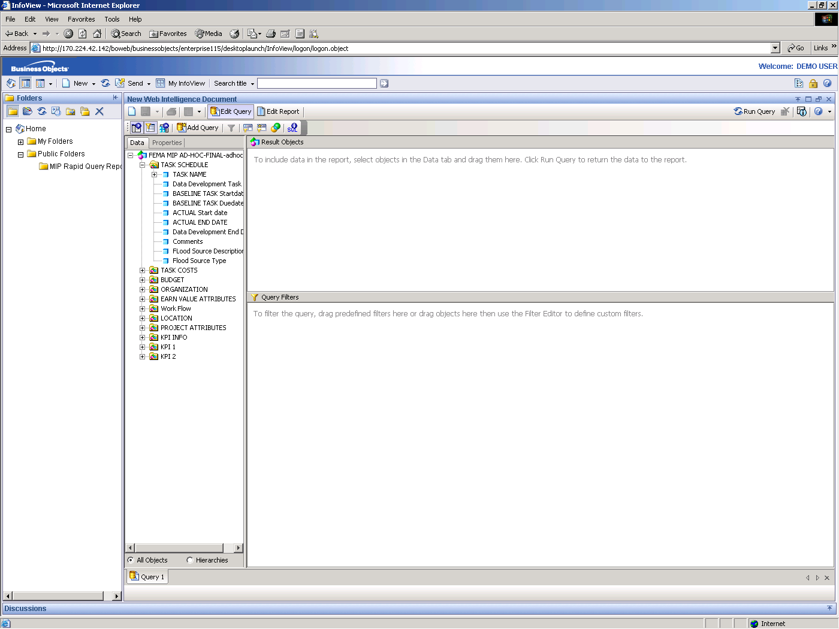 Building a Query
A Business Objects query is created in the Query Panel.

You create a query by placing objects from the Classes and Objects panel into the Result Objects box.

The Query Process

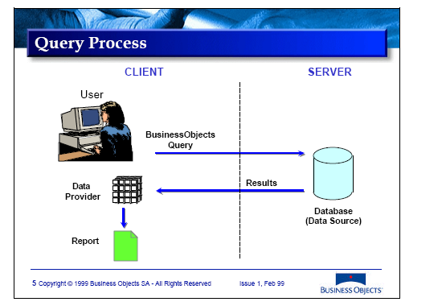

When you run a query, by clicking on the Run button, Business Objects performs the following steps:

- The query is converted into an SQL query.
- The SQL query is sent and applied to the database.
- The aggregated results of the SQL query are returned to the report.
- The results of the query are stored in the data provider.

- The contents of the data provider are displayed in a block in a report in the Business Objects document.

Documents

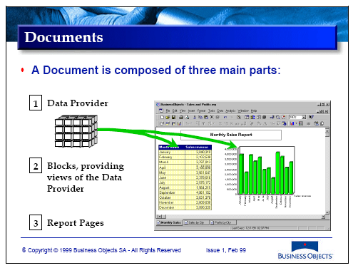

A Business Objects document contains:

- The Data Provider is a structure in which the retrieved data is stored in the document on your computer. It contains the data that can be displayed in the report(s) inside the document. The data can come from your corporate database or from personal data files, or a combination of these.
- Blocks is the generic term used to describe tables, crosstabs and charts containing data from the data provider. Business Objects enables you to combine blocks within a report.
- Reports are the focal point of your work with Business Objects, where you view, analyze and format data. Reports contain blocks of formatted data as well as text and graphics. You can specify layout when you create a report. You can change the layout of existing reports by turning crosstabs and tables into charts and vice versa, by building crosstabs from tables and by switching between chart types. The titles of report pages in a document are shown as tabs in the Business Objects window.

Building a Query

Creating a New Document

Create a new document to hold your query:

- Click the (New) button in the toolbar and select the Web Intelligence Document option to create a new Web Intelligence document.

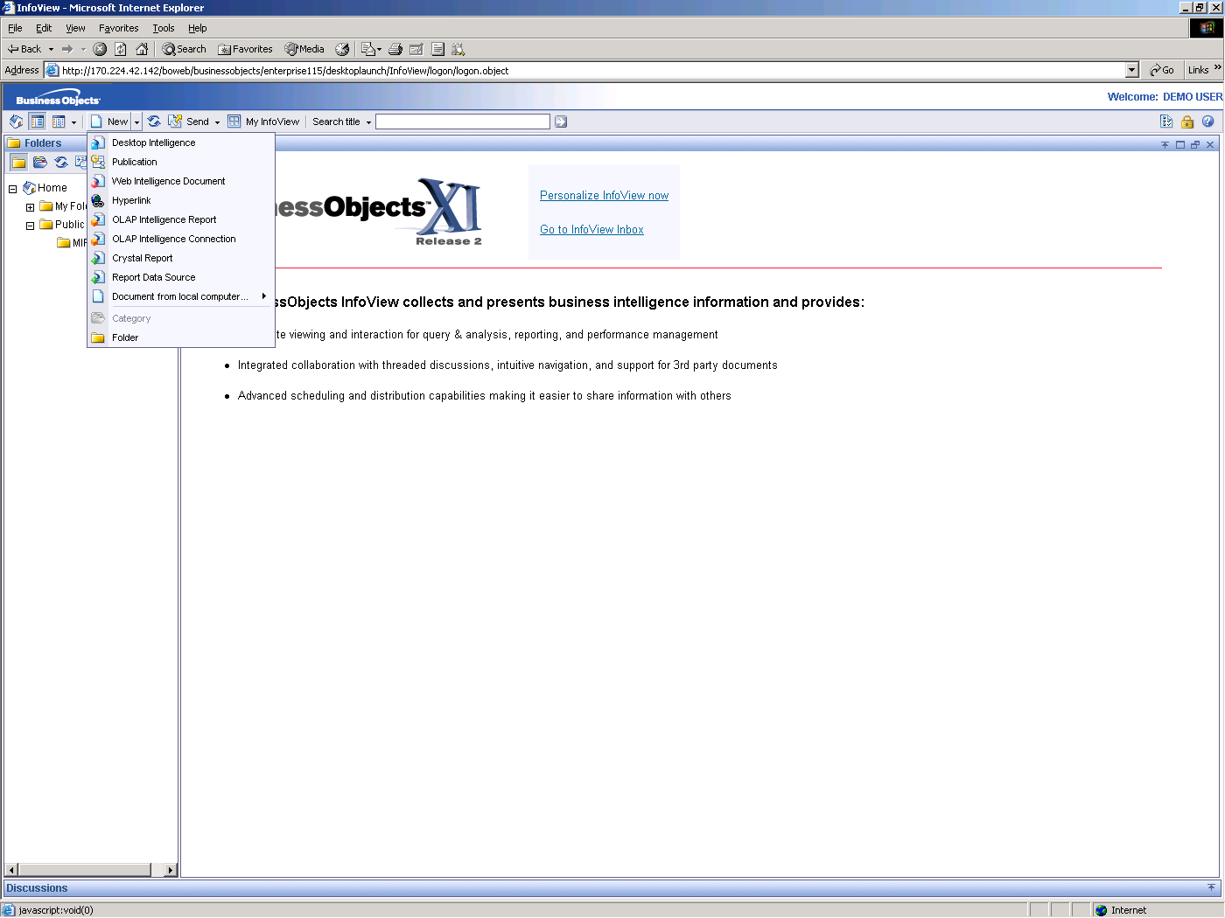

A new Business Objects document is created.

Creating a Query

Creating a query involves the following steps:

- Choosing a Universe for accessing the data.
- Selecting the objects that comprise of the block.
- Executing the query.
Choosing the Universe for accessing the Data

The New Web Intelligence Document window lets you choose which Universe you want to access data from.

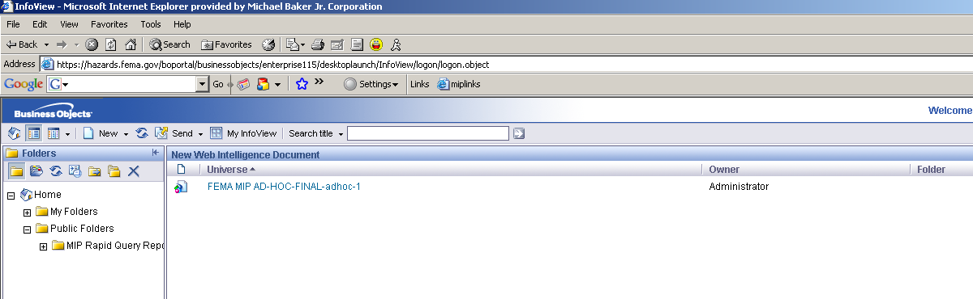

  - Click the Universe that you want to use.

  - This opens the HTML query panel and we need to select the required objects into the result objects pane. After all the objects are selected, we need to run the query to generate the result set in the form of a report.

Classes and Objects

The Classes and Objects box shows you the available classes and objects in your selected Universe. From this box you will select the objects you want in your report.

When the Query Panel opens, the class folders are closed.

Adding and Removing Objects

Objects can be moved into and out of the Result Objects box in several ways.

To add an object to a query, you can:
- Drag-and-drop an object anywhere you want it in the query, or
- Double-click on an object to add the object to the end of the query
To delete an object from a query:
- Drag-and-drop it back into the Classes and Objects box, or
- Right-click on the object and select Remove, or
- Select the object and press the Delete key

Running the Query

To execute the query, click the Run Query button.

The results are displayed as a block of data in the report.

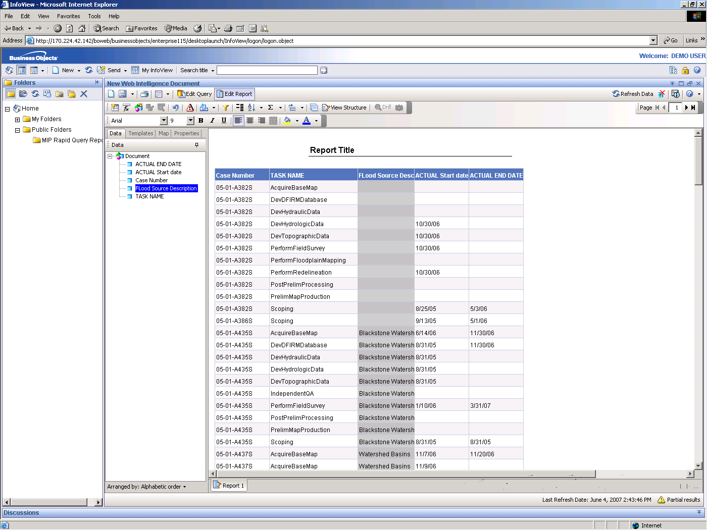

Editing the Results of a Query
In order to modify the query generated, click on the Edit Query button in the menu bar to get back to the Query Panel.

In order to edit the report, select the Edit Report button in the toolbar.

Understanding the Report Manager
The Report Manager is a key part of the workspace from which you can manage many different aspects of your work. The Report Manager offers a comprehensive way of creating, opening, navigating, and manipulating reports.

From one window, you can manage all the variables in your report, work on the structure and formatting of report components, and use the navigation view to go quickly from section to section or report to report.

The Report Manager has two tabs, and each tab has two radio buttons. This combination shows you four distinct views or aspects of your work.

Each tab is used to manage a different aspect of your work in Business Objects.

- The Data tab manages the variables and formulas in reports. This tab contains a list of all the variables and formulas in the document. You can view this list in two different ways:

  - Alphabetical order – the data in the document is listed in alphabetical order with the variables in the Variables folder and the formulas in the Formulas folder.

  - By data provider – the variables are grouped by data provider. You can drag variables and objects from this list and drop them directly into the report window to construct or edit tables and other components. You can also create new variables or edit existing variables in this area.

- The Map tab allows you to navigate through reports and to work on the structure and organization of reports and report components.

  - In the Navigation View, a list of all the reports in the document is displayed. For the report currently displayed on your screen, section names are also displayed. If you click on an item in the list, the corresponding report or section is displayed in the report window.

  - In the Structure View, a list of all the reports in the document and a list of all the components in the selected report are displayed. Each report component (header, section, cell, table, chart etc.) is represented by an icon and a name. The names of components hidden in the report are displayed in italics.

- The Templates and the Properties tabs allow you to add new tables into the report, or to add new cells, tables or graphs, and so on. The properties tab is dynamic as to which objects are selected and will allow us to change the objects’ properties that are selected.

Setting Up a Master/Detail Report
The Report Manager allows you to create master/detail reports. Although it is easy to create master/detail reports using drag-and-drop, the advantage of using the Report Manager is that it can save you the extra step of first placing an object in a table and then sectioning it afterwards.

Scenario

You are working in the Report Manager and need to section your report by Division Name.

To create a master/detail report using the Report Manager:

- Continue using the document that you are currently working on with the selected objects and assume that you have the Case Number, Task Name, The Actual Start Date, the Actual End Date and also the Flood Source Description.

- Click on the Case number and after it is highlighted, select the row again and drag it out of the table to the above corner. The mouse pointer should indicate that this will create a section. Drop the object to create the master detail report as required. Now all the data is segregated by the respective case numbers and grouped by the respective cases. Thus you get a report of all the tasks associated with each project and their respective attributes.

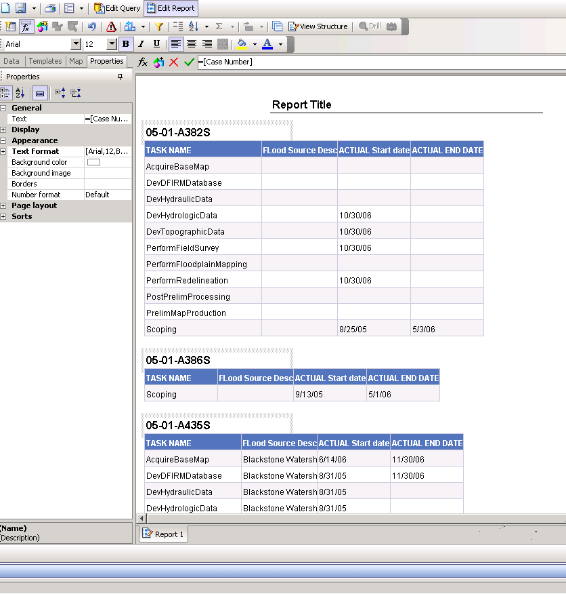

- Use the Map tab and its Navigation and Structure buttons to view and select various parts of your table.

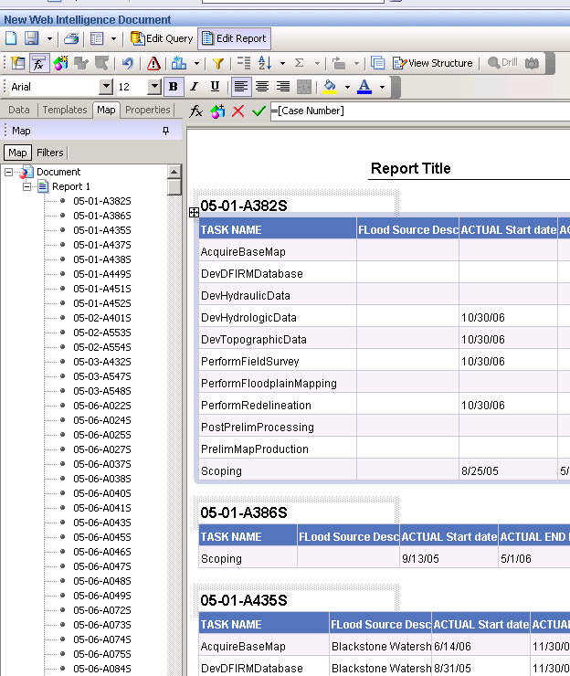

- Save this report with the name demo_fema_1. This can be done by clicking the Save As icon. This will open another dialog box for you to enter the parameters required for saving this document. Enter the parameters and click OK to save the document.

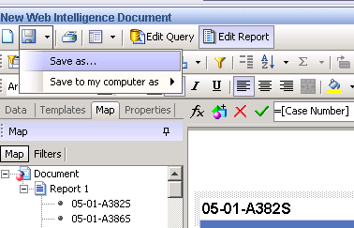
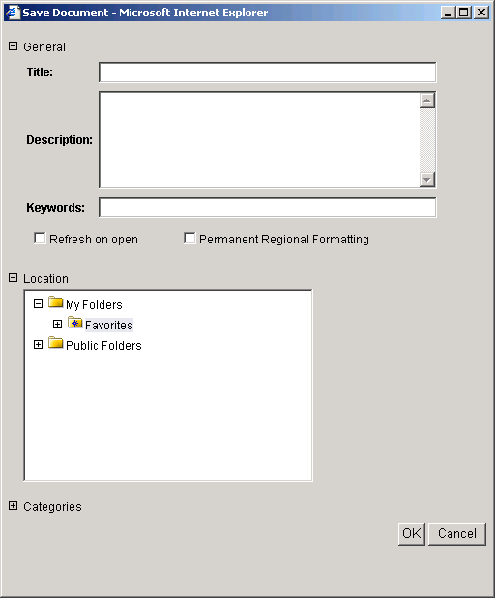

Conditions

Overview
This module describes how to set up query conditions.

By using query conditions, you can limit the data returned from the underlying database.

What you will be able to do

At the end of this module, you will be able to do the following:

- View results for the following conditions:

  - Single value
  - Multi-value
  - Prompted
  - Pattern matching
  - Combined multiple
  - Predefined
- Use the following elements of conditions:
  - Wildcards
  - Relational operators
  - Logical operators
  - Condition objects

Understanding Query Conditions

Sometimes you want to restrict a query so that it returns data related to a subset of values for an object rather than all values. For example, you may wish to produce a report on provider appointments by hospital Meprs Codes (e.g. BGAA) as opposed to all provider appointments.
Other, more complex data requests may want appointments during specific time periods and for specific locations; these requests require more complex, logical conditions.

To achieve this you must set the condition: CID Different from Pattern %C

A condition has three elements. These are:

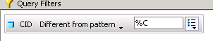

Object

Condition Operator

Operand

These three elements are defined as follows:

- Object – a field or column of data.

- Operand – the object value to be searched for.

- Operator – specification of the relationship between the object and the operand.

You can set simple conditions using the (Simple Condition) button in the Query Panel toolbar. This condition only lets you limit query results for a result object by selecting from a list of values. This module takes you further by introducing more complex conditions.

There are four types of conditions, explained in the following sections, that you can use in Business Objects:

- Single- and multi-value conditions

- Prompted condition
- Multiple condition

- Predefined condition

Applying Prompted Conditions
When you use a prompted query condition, Business Objects asks you to choose which data to retrieve before running the query.

Scenario

You need to produce a report showing future appointments for all providers based on the current date the user specifies when running the query.

To set a prompted condition:

- Create a new document.

- Create a query using Region, State, Case Number, and Appeal Period Start Date.

- Create a condition using the object Case Number and the operator In List.

The Query Panel displays your query and condition as follows.

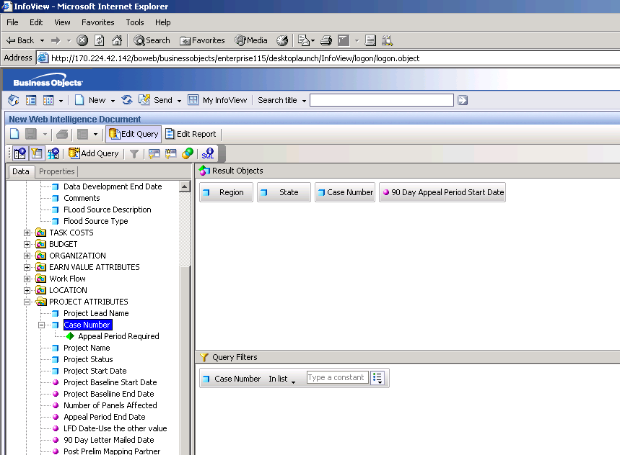

- Click on the Drop Down and select Prompt. The entry will then change to the Enter Case Numbers: value. This is the name of the prompt that the users will get when they run the query.

- Click Run to run the query.

Business Objects displays a message box prompting you (using the question you typed in Step 4) to enter a value.

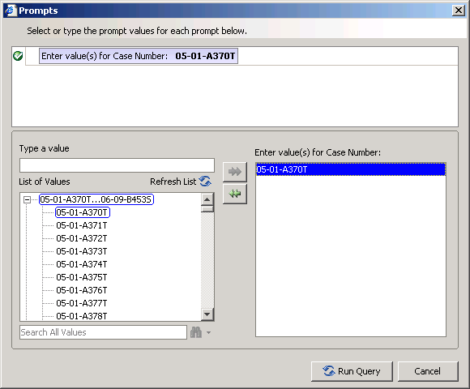

Once you enter the required value, we need to run the query only for these case numbers.

Manipulating Data using Simple Calculations, Sorts, and Filters

Overview
This module describes how to resize columns and rows in tables, change the order in which columns are displayed, add simple calculations and apply sorts and filters. These skills allow you to develop the layout and presentation of your reports to make the information more accessible.

What you will be able to do

At the end of this module, you will be able to:
- Resize columns and rows so that data can be viewed
- Change the order in which columns are displayed
- Change table column titles
- Format all the cells from the properties tab

Manipulating Tables

Resizing Columns and Rows

- Create a new document.
- Create a query using Region, State, Project Name and 90 Day Appeal Period Start Date
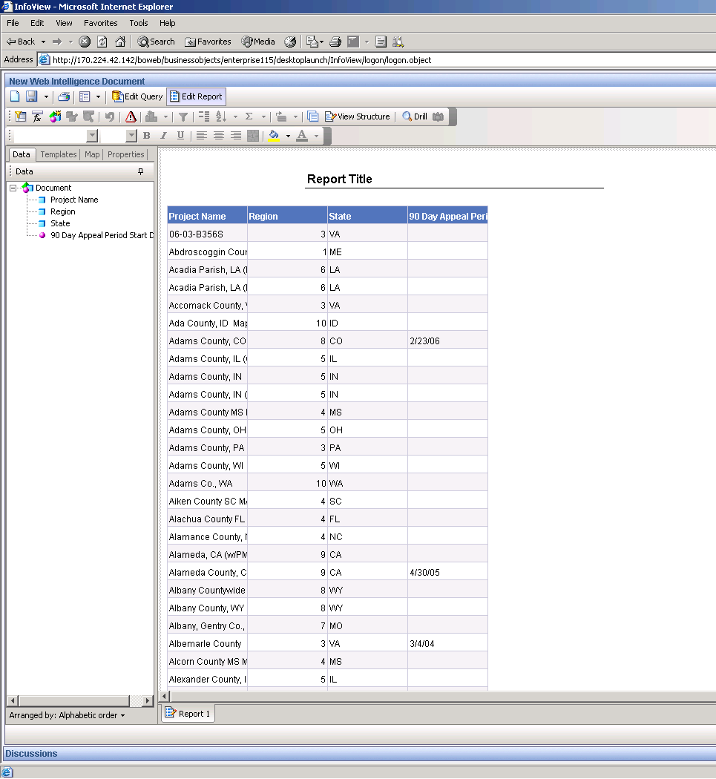
This document contains a table. Notice that the columns are not formatted very well. For example:
  - You can’t see the project names properly in the left hand column.
  - The row height is small.
All of these presentation faults can be changed using table formatting options.

Manual Resizing

You can resize the columns and rows manually as follows:

- Position the mouse pointer on the border between the Project Name and Region columns.
The pointer changes to a

- Press and hold down the left mouse key and drag the border to the required width.
To manually resize the height of all rows in the table:

- Position the mouse pointer on any row border.
The pointer changes to a

- Press and hold down the left mouse key and drag the border to the required height.

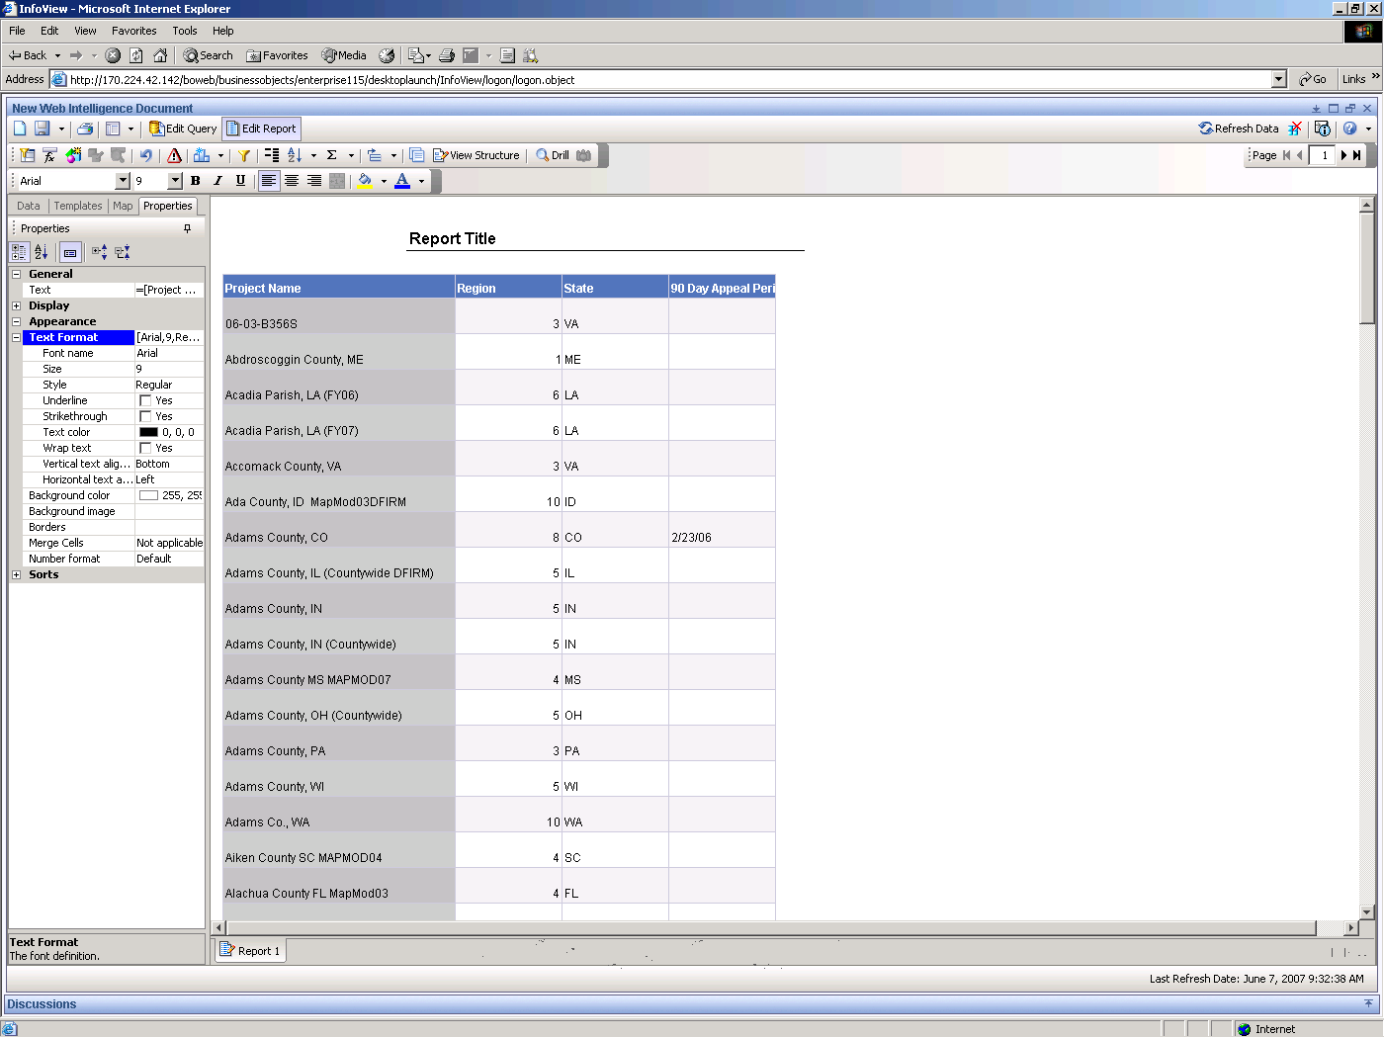

Note: Notice that the height of all the rows in the table has changed, but not the heading row.

- Position the mouse on the bottom border of the table heading row.
- Drag the heading border to the required height.

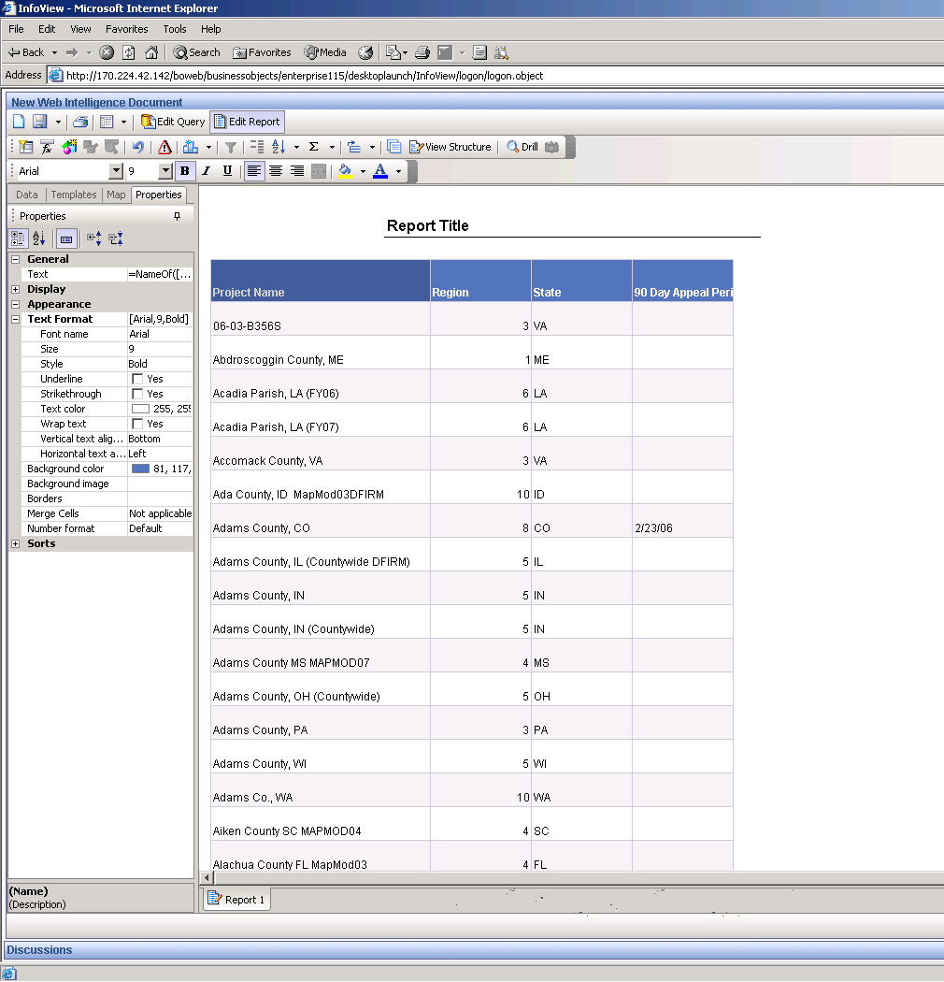
Automatic Resizing
Business Objects also has some automatic formatting feature to help you improve the look of your tables.

To resize a column automatically:

- Position the mouse pointer on the border between the Project Name and Region columns.
- When the pointer changes to a , double-click the left mouse key and the column will resize automatically.

To resize rows automatically:

- Position the mouse pointer on any row border.
- When the pointer changes to a , double-click the left mouse key and the rows will resize automatically.
- Automatically resize the heading row as well.

Using the Wrap Feature

You can also specify all the properties of the column or cell by selecting the cell and then clicking on the properties tab on the left hand side. The properties of the selected object are displayed in the tab.

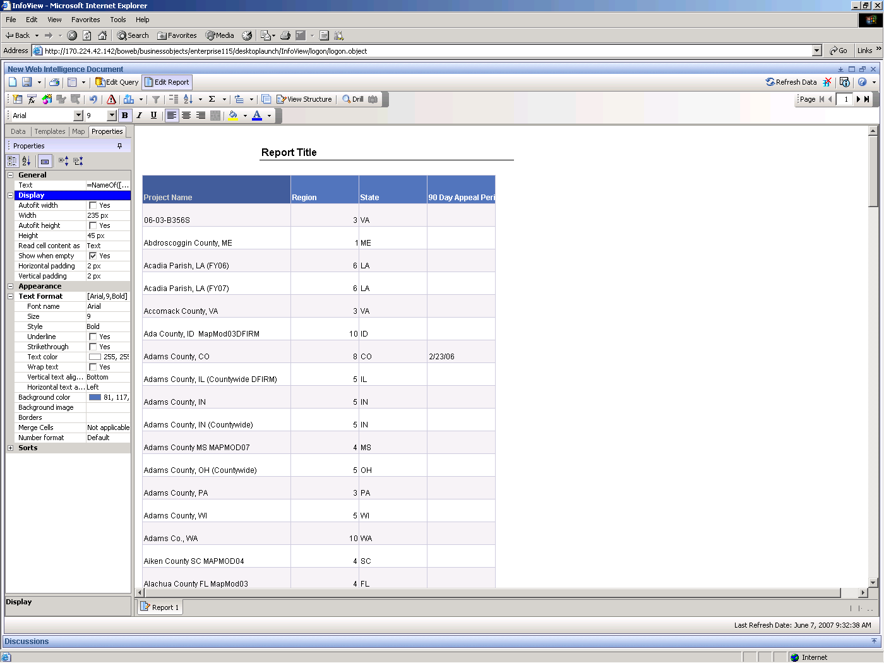

Moving Columns
If you want to change the order of the columns in a table, you can simply drag-and-drop them in the order you want.

To move a column of data in a table:
- Select the Region column of data by clicking the data area with the left mouse button.

- Drag the Region column to the left of the Project Name column.
- Drop the column.
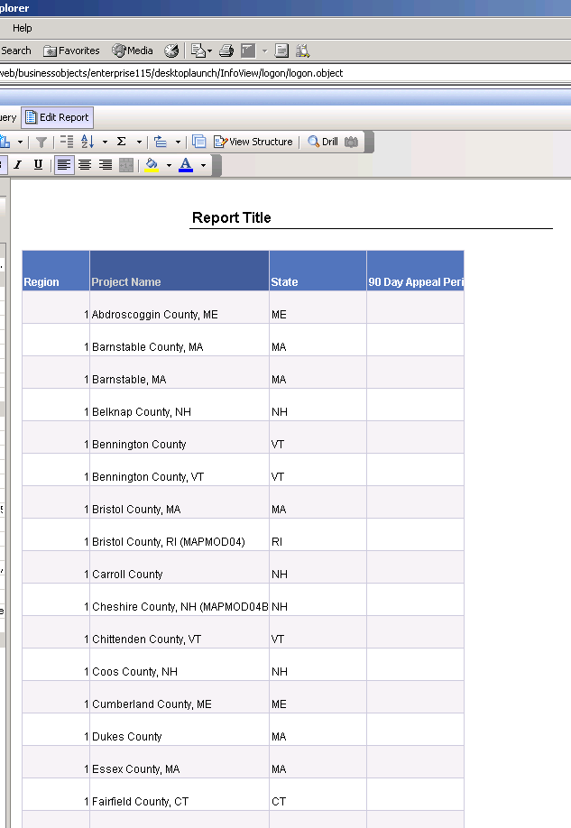

Tip: Remember, if you make a mistake, you can always undo it.

- Try the drag-and-drop technique again. This time, select the State column of data by clicking the data area with the left mouse button.
- Drag the State column to the left of the Project Name column.
- Drop the column.

Changing Column Titles
By default, Business Objects uses the names assigned to your data as the column titles in your tables. Sometimes the default name may not be suitable, so Business Objects lets you change the names.

To change a default column title in a table:

- Double-click on the Project Name column heading.

The heading is highlighted and the cursor is displayed in the formulae toolbar. Change the column heading to the new name: Project.

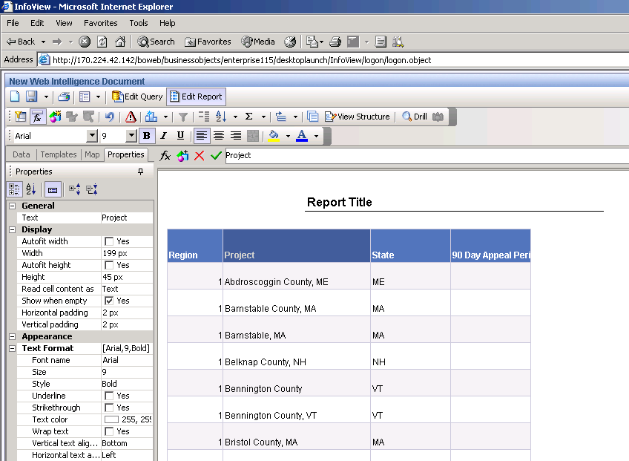

The heading is changed.

Scheduling and Emailing Reports

This module describes how to schedule and e-mail any report.

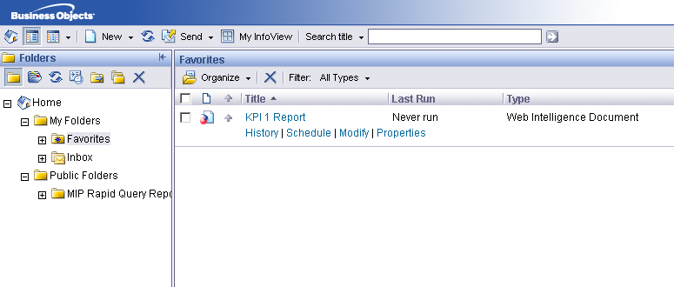

You can schedule and email reports only under your “Favorites” folder.

- Click on “Schedule” link under any report
- This opens the “Schedule” page.
- Expand the “Format” heading and select “Adobe Acrobat”.

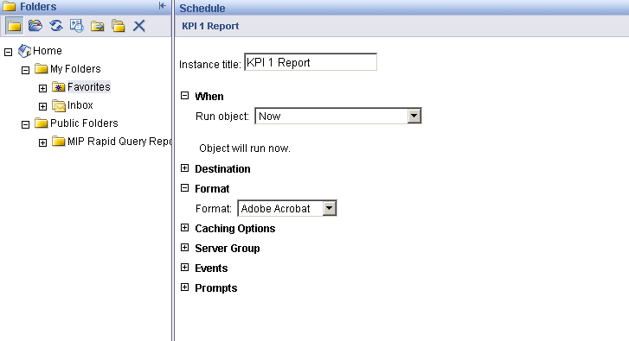

- Expand the “Destination” heading, select “Email recipients” from the drop down box and uncheck the “Use the Job Server’s defaults” setting.

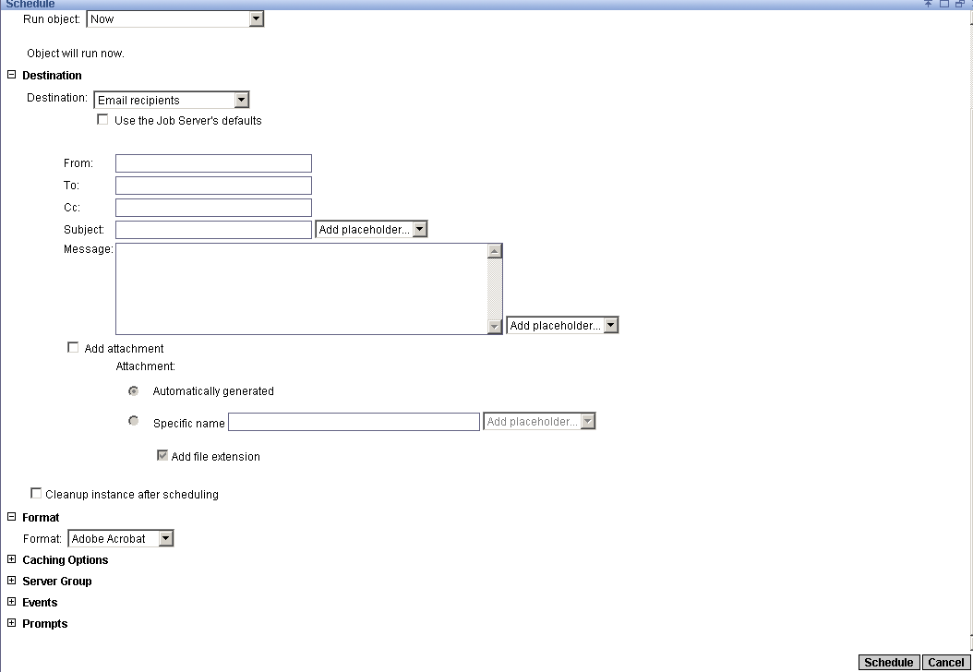

- Type “From” address, “To” address and remember to check “Add attachment”.
- Click on a “Schedule” button in right bottom corner to send an e-mail.

